COLLOQUIUM
Hema Srinivasan
University of Missouri
“On Resolutions of Powers of Determinantal Ideals”

Thursday, November 7, 2013 at 3:30 p.m. in CH 113
Refreshments will be served in Math 238 at 3:00 p.m.

Abstract

Let  be an matrix with entries in a ring . Then the ideal of 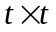 minors, denoted by 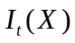 is called a determinantal ideal. It is well known that the height of is at most 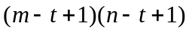 and the resolution of 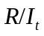 in characteristic zero is known for all and characteristic free description for the ideal of maximal and submaximal minors are known by the works of Eagon, Northcott, Buchsbaum, Akin, Weyman and Lasoux. However, not much is known about the resolution for the powers of these ideals. We will discuss the resolutions of and 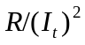 when is a square matrix of size less than 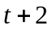. We will provide the general background in the colloquium, leaving the more technical new results for the seminar.

